**Name : Ahsan Raza Talpur**

**Roll number : (2k23/BLCS/06)**

**Department : Computer Science (1st year)**

**Assignment : Object Oriented Program Structure**

**(Java)**

**Professor : Sir Altaf Hussain Abro**

**Campus : Laar Campus Badin**

**Q.No.1. Write a program to print the first 30 odd and even numbers, also display sum of all even and odd numbers separately. (By using Loop)** .

Even numbers Odd numbers

02 01

04 03

06 05

08 07

-- --

------------------------------------------------------------------------

Sum: --- ----

**Source code :**

class EvenOdd

{

public static void main(String args[])

{

int even=0,odd=0;

System.out.print("\tEven numbers Odd numbers");

System.out.println();

for(int a=1;a<=30;a++)

{

if(a%2==0)

{

even+=a;

System.out.println("\t\t"+a+"\t");

}

else

{

odd+=a;

System.out.print("\t "+a);

}

}

System.out.println("------------------------------");

System.out.println("Sum :"+ "\t"+even+" \t\t"+odd);

}

}

**Output:**

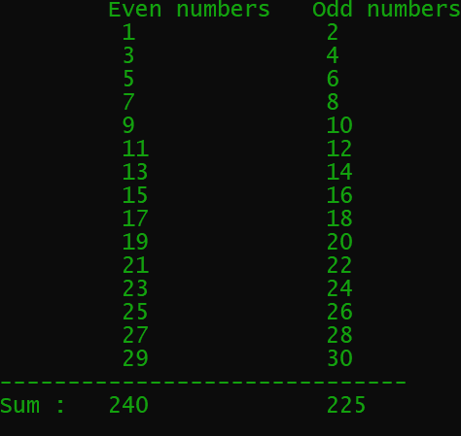

**Q.No.2. Write a program that asks the user to enter Basic pay and print pay-slip of the Employee.**

Please enter Basic pay?40000

Pay Slip

Basic pay :40000

House Rent (40%) :10160

Medical All ounce (18%) :5000

Computer Allowance(15%) :5000

-----------------------------------------------------------------------------

Total pay: : ----

**Source code :**

import java.util.Scanner;

class Paysilp

{

public static void main(String args[])

{

Scanner sc =new Scanner(System.in);

System.out.println("Please enter Basic pay ?");

Double basicpay=sc.nextDouble();

Double houserent =4.0*basicpay;

Double medicalallounce = 18.0*basicpay;

Double computerallounce = 15.0*basicpay;

Double totalpay = basicpay+houserent+medicalallounce+computerallounce;

System.out.println(" \t Paysilp");

System.out.println("Basic pay :"+basicpay);

System.out.println("House Rent (40%) :"+houserent);

System.out.println("Medical Allounce (18%) :" +medicalallounce);

System.out.println("Computer Allounce (15%) :"+computerallounce);

System.out.println("--------------------------------------------");

System.out.println("Total Pay :"+totalpay);

}

}

**Output :**

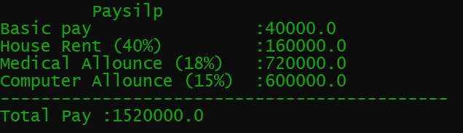

**Q.No.3. Write a program to print the following series. (By using Loop)**

1. **1 4 9 16 25 36 49 . . . . . . 100**
2. **1 8 27 64 . . . . . . . . . . 1000**
3. **3 6 10 15 21 28 36**

**Source Code :**

class Series{

public static void main(String args[])

{

for(int a=1;a<=10;a++)

{

int square=a*a;

System.out.print(square+" ");

}

System.out.println( );

for(int a=1;a<=10;a++){

System.out.print(a*a*a+" ");

}

System.out.println();

int n=1;

for(int a=2;a<=8;a++)

{

n+=a;

System.out.print(n+" ");

}

}

}

**Output :**

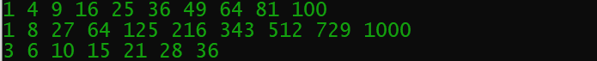

**Q.No.4. Write a program to calculate area of square.**

**Source code :**

import java.util.Scanner;

class AreaSquare

{

public static void main(String args[])

{

Scanner in = new Scanner(System.in);

System.out.print("Enter number of square :");

int area=in.nextInt();

double areasquare=area*area;

System.out.println("Area of Square is :"+areasquare);

}

}

**Output:**



**Q.No.5. Write a program to calculate area of rectangle.**

**Source code :**

import java.util.Scanner;

class AreaRectangle

{

public static void main(String args[])

{

Scanner sc = new Scanner(System.in);

System.out.print("Enter width of rectangle :");

double width=sc.nextDouble();

System.out.print("Enter length of rectangle :");

double length=sc.nextDouble();

double arearectangle =width*length;

System.out.print("Area of Rectangle is :"+arearectangle);

}

}

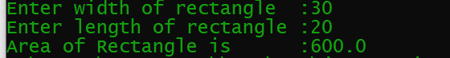

**Q.No.6. Write a program to convert a given amount in notes/coins?**

**Example:**

**Enter any amount? 9897 Output:**

**1000 500 100 50 20 10 5 2 1**

**9 1 3 1 2 0 1 1 0**

**Source code:**

import java.util.Scanner;

class Notes {

public static void main(String args[])

{

Scanner sc=new Scanner(System.in);

System.out.print("\nEnter Amount: ");

int amount= sc.nextInt();

int note1=amount/1000;

amount=amount%1000;

int note2=amount/500;

amount=amount%500;

int note3=amount/100;

amount=amount%100;

int note4=amount/50;

amount=amount%50;

int note5=amount/20;

amount=amount%20;

int note6=amount/10;

amount=amount%10;

int note7=amount/5;

amount=amount%5;

int note8=amount/2;

amount=amount%2;

int note9=amount/1;

System.out.println("\n1000\t500\t100\t50\t20\t10\t5\t2\t1");

System.out.println(note1+"\t"+note2+"\t"+note3+"\t"+note4+"\t"+note5+"\t"+note6+"\t"+note7+"\t"+note8+"\t"+note9+"\t"); }

}

**Output:**

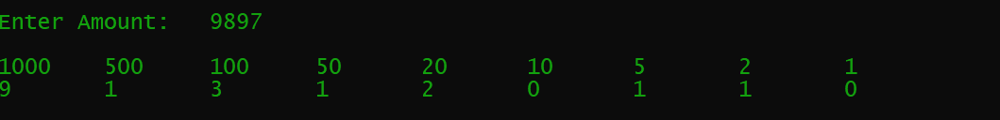

**Q.No.7. Write a program to take input of Seat No, Subjects & Marks of a student & calculate the total & percentage, & display the output in table format.**

**Example:**

**M A R K S H E E T**

|  |  |  |
| --- | --- | --- |
| **Roll No** | **Subjects** | **Marks** |
| **2k18/CS/01** | **English** | **80** |
| **2k18/CS/01** | **Basic Electronics** | **60** |
| **2k18/CS/01** | **Mathematics** | **50** |
| **2k18/CS/01** | **Introduction to Computers** | **70** |
| **2k18/CS/01** | **Computer Language** | **50** |

**Total Marks :** 310

Percentage % : 62.00

**Source code :**

import java.util.Scanner;

class Marksheet

{

public static void main(String args[])

{

Scanner in = new Scanner(System.in);

System.out.print("Enter Your Roll number :");

String rollno=in.nextLine();

// subject name

System.out.print("Enter subject1 :");

String sub1=in.nextLine();

System.out.print("Enter subject2 :");

String sub2=in.nextLine();

System.out.print("Enter subject3 :");

String sub3=in.nextLine();

System.out.print("Enter subject4 :");

String sub4=in.nextLine();

System.out.print("Enter subject5 :");

String sub5=in.nextLine();

// subject marks

System.out.print("Enter"+" "+sub1+" "+"marks :");

int mark1=in.nextInt();

System.out.print("Enter"+" "+sub2+" "+"marks :");

int mark2=in.nextInt();

System.out.print("Enter"+" "+sub3+" "+"marks :");

int mark3=in.nextInt();

System.out.print("Enter"+" "+sub4+" "+"marks :");

int mark4=in.nextInt();

System.out.print("Enter"+" "+sub5+" "+"marks :");

int mark5=in.nextInt();

int totalmarks=mark1+mark2+mark3+mark4+mark5;

float percentage =100*totalmarks/500;

//output

System.out.println(" M A R K S H E E t");

System.out.println("Roll No Subjects Marks");

System.out.println(rollno+" "+sub1+" "+mark1);

System.out.println(rollno+" "+sub2+" "+mark2);

System.out.println(rollno+" "+sub3+" "+mark3);

System.out.println(rollno+" "+sub4+" "+mark4);

System.out.println(rollno+" "+sub5+" "+mark5);

System.out.println(" "+"Total Marks :"+totalmarks);

System.out.println(" "+"Percentage % :"+percentage);

}}

**Output:**

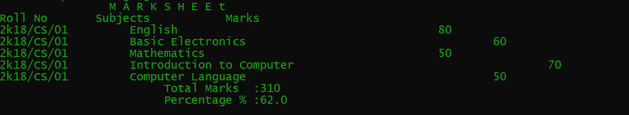

**Q.No.8. Write a program to calculate area of circle.**

**Source code :**

import java.util.Scanner;

class AreaCircle{

public static void main(String args[])

{

Scanner in =new Scanner(System.in);

System.out.print("Enter radius of circle : ");

double raduis=in.nextDouble();

double area =Math.PI*raduis*raduis;

System.out.print("Area of circle is :"+area);

}

}

**Output:**



**Q.No.9. Write a program to generate multiplication table. (By using Loop) output:**

**Enter table no? 8**

**Start from? 2**

**Up to ? 7**

**Table-8**

* 1. **\* 8 = 16**
  2. **\* 8 = 24**
  3. **\* 8 = 32**
  4. **\* 8 = 40**
  5. **\* 8 = 48**
  6. **\* 8 = 56**

**--------------------------------------**

**Sum: 27 48 216**

**Source code:**

import java.util.Scanner;

class Table

{

public static void main(String[] args) {

Scanner in = new Scanner(System.in);

System.out.print("Enter Table no ?");

int a=in.nextInt();

System.out.print("Start from ?");

int b=in.nextInt();

System.out.print("upto ?");

int c=in.nextInt();

System.out.println("Enter table no?"+" "+a);

System.out.println("Start from ?"+" "+b);

System.out.println("Up to ?"+" "+c);

int sum=0;int n=0;int ressum=0;

for(int i=b;i<=c;i++)

{

int result=i*a;

System.out.println(" "+i+" "+"x"+" "+a+" "+result);

sum +=i;

//sum+=a;

n+=a;

ressum+=a*i;

}

System.out.println("--------------------------");

System.out.print("Sum :"+sum+" "+n+" "+ressum);

in.close();

}

}

**Output**

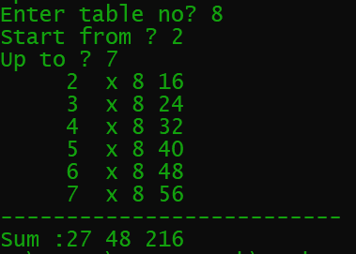

**Q.No.10. Write a program to convert a given Seconds into Hours, Minutes and Seconds?**

**Output:**

**Input Seconds? -----**

**Hours Minutes Seconds**

**--- ---- ----**

**Source code:**

import java.util.Scanner;

class Time1

{

public static void main(String[] args) {

Scanner in =new Scanner(System.in);

System.out.println("Enter Secounds :");

int seconds=in.nextInt();

System.out.println("Hour Minutes Seconds");

int hour=seconds/3600;

int min=(seconds%3600)/60;

int sec=(seconds%3600)%60;

System.out.print(hour+" "+min+" "+sec);

}

}

**Output :**

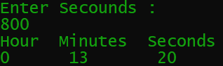

**Q.No.11. Write a**  [**Program to find the largest and smallest number from given 10 numbers.**](http://www.c4learn.com/c-programs/c-program-to-find-greatest-in-3-numbers.html)

**Example:**

**Enter any 10 integer numbers? 4 6 12 56 3 8 34 32 40 22**

**Largest number : 56**

**Smallest number : 3**

**Source code:**

import java.util.Scanner;

class Minmax {

public static void main(String[] args)

{

Scanner in = new Scanner(System.in);

int max = Integer.MIN_VALUE;

int min = Integer.MAX_VALUE;

System.out.print("Enter any 10 integers: ");

for (int i = 0; i < 10; i++)

{

int num = in.nextInt();

if (num > max)

{

max = num;

}

if (num < min)

{

min = num;

}

}

System.out.println("largest number : " + max);

System.out.println("Smallest number: " + min);

}

}

**Output:**

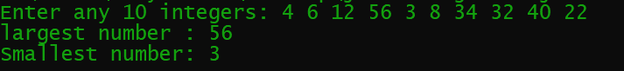

**Q.No.12. Write a program that asks the user to enter two numbers, and prints the sum, product, difference, quotient and remainder of the two numbers.**

**Please enter two numbers ? 9 4**

**Sum of 9 and 4 is: 13**

**Product of 9 and 4 is: 36**

**Difference of 9 and 4 is: 05**

**Quotient of 9 and 4 is: 02**

**Remainder of 9 and 4 is: 01**

**------------------------------------------------**

**Total is: 57**

**Source code:**

import java.util.Scanner;

class Operation {

public static void main(String args[])

{

Scanner in = new Scanner(System.in);

System.out.println("Please enter two numbers:");

int input1 = in.nextInt();

int input2 = in.nextInt();

int sum = input1 + input2;

int product = input1 * input2;

int difference = input1 - input2;

int quotient = input1 / input2 ;

int remainder = input1 % input2 ;

System.out.println("Sum of " + input1 + " and " + input2 + " is " + sum);

System.out.println("Product of " + input1 + " and " + input2 + " is " + product);

System.out.println("Difference of " + input1 + " and " + input2 + " is " + difference);

System.out.println("Quotient of " + input1 + " and " + input2 + " is " + quotient);

System.out.println("Remainder of " + input1 + " and " + input2 + " is " + remainder);

int total = sum + product + difference + quotient + remainder;

System.out.println("---------------------------------------");

System.out.println("Total is : "+total);

}

}

**Output:**

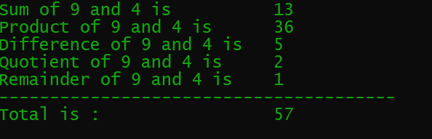

**Q.No.13. Write a program to convert binary number to octal number. Output:**

**Enter any binary number? 1 1 0 1 0 1 1 1**

**Octal number is : 327**

**Source code:**

import java.util.Scanner;

class Conversion

{

public static void main(String[] args)

{

long input,bin,deci=0,remain;

long []octal = new long[1000];

long power = 0;

int i;

int j;

System.out.print("Enter any binary number: ");

Scanner scan = new Scanner(System.in);

input = scan.nextLong();

bin = input;

for( i = 0 ; bin != 0 ; i++)

{

remain = bin % 10;

deci += (long)(remain * Math.pow(2,power));

bin = bin /10;

power++;

}

for( i = 0 ; deci != 0 ; i++){

remain = deci % 8;

octal[i] = remain;

deci = deci / 8;

}

System.out.print("octal number is : ");

for(j = i -1 ; j >= 0 ; j--){

System.out.print(octal[j]);

}

}

}

**Output:**

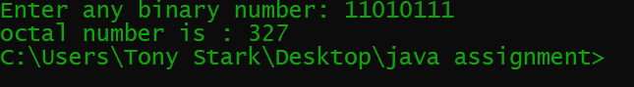

**Q.No.14. Write a program to display following output: (By using Loop) Example:**

**enter 1st number =1**

**enter last number=10**

**sum is: 1+2+3+4+5+6+7+8+9+10 = 55**

**Source code:**

import java.util.Scanner;

class Main{

public static void main(String[] args) {

int input1;

int input2;

int sum = 0;

Scanner scan = new Scanner(System.in);

System.out.print ("Enter first number: ");

input1 = scan.nextInt();

System.out.print("Enter last number: ");

input2 = scan.nextInt();

System.out.print("sum is: ");

for(int i = input1 ; i <= input2 ; i++)

{if(i == input2){

System.out.print(i + " = ");

sum +=i;

}

else{

System.out.print(i + " + ");

sum += i;}

}

System.out.println(sum);

}

}

**Output:**

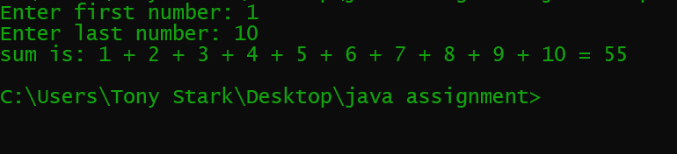

**Q.No.15. Write a program to convert a given number of Days in terms of Years, Weeks and Days.**

**Source code:**

import java.util.Scanner;

class Days

{

public static void main(String args[])

{

Scanner in =new Scanner(System.in);

System.out.println("Enter number of days");

int days =in.nextInt();

int year = days / 365;

days = days % 365;

int month = days / 30;

days = days % 30;

int weak = days / 7;

days = days %7;

System.out.println("Years\tmonths\t weaks\t Days");

System.out.println(year+" "+month+" "+weak+" "+days);

}

}

**Output :**

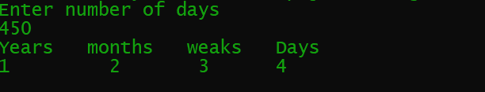

**Q.No.16. Write a program that calculates the squares and cubes to print the output as under: (By using Loop)**

**Output:**

**Start from -------------------------------------? 3**

**Up to -------------------------------------------? 7**

**Number Square Cube**

1. **09 27**
2. **16 64**
3. **25 125**
4. **36 216**
5. **49 343**

**==== ===============================**

**Sum: 25 135 775**

**Source code:**

import java.util.Scanner;

class Squarecube {

public static void main(String args[])

{

int start,Upto,n=0,s=0,q=0;

Scanner sc=new Scanner(System.in);

System.out.print("Start from.................? ");

start= sc.nextInt();

System.out.print("Up to......................? ");

Upto= sc.nextInt();

System.out.println("\tNumber\tSquare\tCube");

for(;start<=Upto;start++) {

System.out.print("\t"+start+"\t"+start*start+"\t"+start*start*start+"\n");

n=start+n;

s=start*start+s;

q=start*start*start+q; }

System.out.println("=== =========================");

System.out.println("sum:\t"+n+"\t"+s+"\t"+q);

}

}

**Output:**

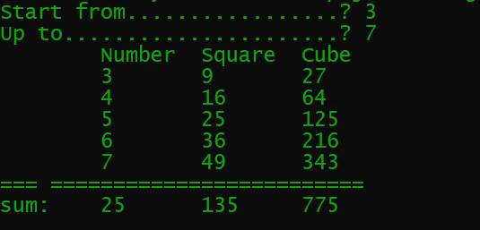

**Q.No.17. Write a program to find first Ten numbers Divisible by 5. (By using Loop) Example:**

**Output: 5 10 15 20 25 30 35 40 45 50**

**Source code:**

class Divisible5 {

public static void main(String args[])

{

int a;

b=5;

System.out.print("Output:\t");

for(a=1;a<=10;a++)

System.out.print(a*b+"\t");

}

}

**Output:**



**Q.No.18. Write a program to read two integers N1 and N2 and Swap their values.**

**Output: Enter value of N1 ? 72**

**Enter value of N2 ? 38**

**Value of N1 is : 38 Value of N2 is : 72**

**Source code:**

import java.util.Scanner;

class Swamp {

public static void main(String args[])

{

int N1,N2,tam;

Scanner sc=new Scanner(System.in);

System.out.print("\nEnter value of N1: ");

N1= sc.nextInt();

System.out.print("Enter value N2: ");

N2= sc.nextInt();

tam=N1;

N1=N2;

N2=tam;

System.out.print("\t\tValue of N1 is: "+N1);

System.out.println("\n\t\tValue of N2 is: "+N2);

}

}

**Output:**

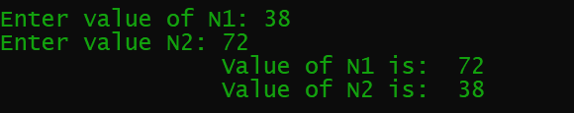

**Q.No.19. Write a program to convert decimal number into binary number?**

**Sample output:**

**Enter any decimal number: 50**

**Equivalent binary value of decimal number 50: 110010**

**Source code:**

import java.util.Scanner;

class Decimaltobinary{

public static void main(String[] args) {

Scanner sc= new Scanner(System.in);

int decimal,temp,module;

System.out.print("\n\tEnter any Decimal Number: ");

decimal=sc.nextInt();

String binary="";

temp=decimal;

while (temp>0) {

module= temp%2;

temp=temp/2;

binary=module+binary;

}

System.out.println("\tEquivalent binary value of decimal number "+decimal+" : "+binary );

}

}

**Output:**



**Q.No.20. Write a program that inputs one five-digit number, separates the number into its individual digits and prints the digits separated from one another by three spaces and also print sum of five-digits?**

## Output:

**Please enter five-digit number ? 43215**

**Separated from one another by three spaces: 4 3 2 1 5 Sum of five digits: 15**

**Source code:**

import java.util.Scanner;

class Fivedigit {

public static void main(String args [])

{

int number,number1,number2,number3,number4,number5,sum;

Scanner input= new Scanner(System.in);

System.out.print("\n\tPlease enter five-digit number ?");

number= input.nextInt();

number1= number%10;

number=number/10;

number2= number%10;

number= number/10;

number3= number%10;

number= number/10;

number4= number%10;

number= number/10;

number5= number%10;

sum=number1+number2+number3+number4+number5;

System.out.println("\n\tSeparated from one another by three spaces: "+number5+" "+number4+" "+number3+" "+number2+" "+number1);

System.out.println("\tSum of five digits: "+sum);

}

}

**Output:**

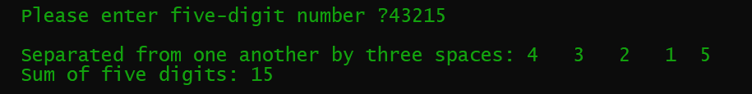

**Q.No.21. Write a program to print ASCII value of all characters**

**Source code:**

class Ascii{

public static void main(String args[])

{

char ch;

int value;

System.out.print("\nASCII Value\tCharacter");

for(value=32;value<=128;value++) {

System.out.print(value);

ch=(char)value;

System.out.print("\t\t"+ch+"\n");

}

}

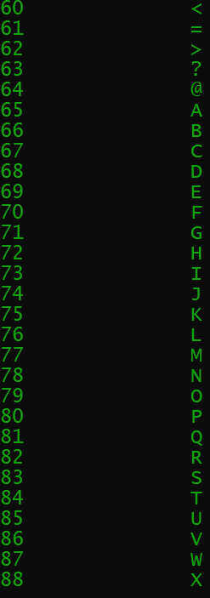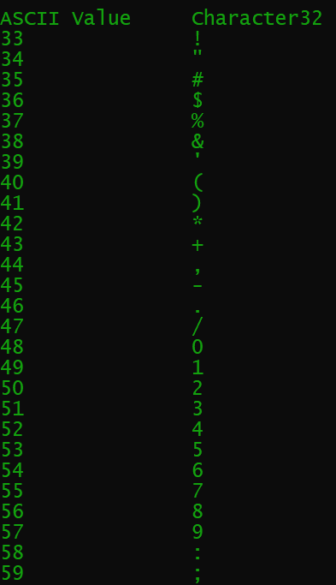**Output:**

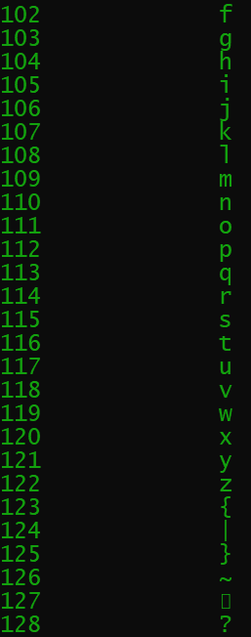 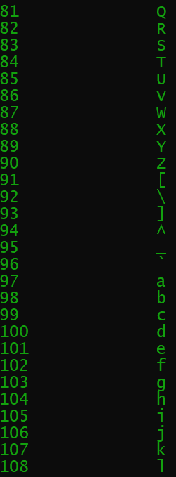

**Q.No.22. Write a program to reverse any number. output:**

**Enter any number? 3452**

**Reverse of 3452 is: 2543**

**Source code:**

import java.util.Scanner;

class Reverse {

public static void main(String args[])

{

int num,reversed=0,digit;

Scanner sc=new Scanner(System.in);

System.out.print("Enter any Number: ");

num= sc.nextInt();

System.out.print("Reversed of "+num+"is: ");

for(;num!=0;num/=10) {

digit=num % 10;

reversed=reversed*10+digit;

}

System.out.print(reversed);

}

}

**Output:**



**Q.No.23. Write a program to convert binary number to Hexadecimal number.**

# **Output:**

**Enter any binary number? 1 1 0 0 1 1 0 1 0 1**

**Hexadecimal number is : 335**

**Source code:**

import java.util.Scanner;

class Hexadecimal{

public static void main(String[] args) {

Scanner input= new Scanner(System.in);

int hexa=0, base=1;

System.out.print("\n\tEnter any binary number? ");

int binary = input.nextInt();

while (binary>0) {

int reminder = binary % 10;

hexa = hexa + reminder * base;

base = base * 2;

binary = binary / 10;

}

System.out.println("\tHexaDecimal Number is:"+hexa);

}

}

**Output:**

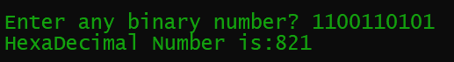

**Q.No.24 Write a program to count the number of words, where a word is defined as any continuous sequence of non-whitespace character Example: input any string? "Laar Campus Badin " output: The string has 3 words**

**Source code:**

import java.util.Scanner;

class Numberofword{

public static void main(String[] args) {

Scanner input= new Scanner(System.in);

System.out.print("\nInput any String?:");

String str= input.nextLine();

int count=1;

for (int i=0; i<str.length()-1; i++){

if (str.charAt(i)==' '){

count++;

}

}

System.out.println("Output: The String has " +count+" words");

}

}

**Output:**

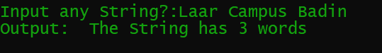

**Q.No.25 Write a Java program to add two binary numbers.**

**Input Data:**

**Input first binary number: 10**

**Input second binary number: 11**

**Expected Output**

**Sum of two binary numbers: 101**

**Source code:**

import java.util.Scanner;

class Addbinary{

public static void main(String[] args) {

int i=0, carry=0;

Scanner sc= new Scanner(System.in);

System.out.print("\nInput Data:\nInput first binary number: ");

Long b1= sc.nextLong();

System.out.print("Input second binary number: ");

Long b2= sc.nextLong();

int[] sum= new int[10];

while(b1 !=0 || b2!= 0) {

sum[i++] = (int) ((b1 % 10 + b2 % 10 + carry) % 2);

carry = (int) ((b1 % 10 + b2 % 10 + carry) / 2);

b1 = b1 / 10;

b2 = b2 / 10;

}

if (carry!=0){

sum[i++]= carry;

}

--i;

System.out.print("Expected Output:\n\nSum of two binary numbers : ");

while(i>=0){

System.out.print(sum[i--]);

}

System.out.print("\n");

}

}

**Output:**

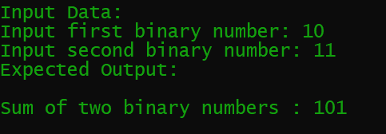

**Q.No.26 Write a Java program to reverse your name.**

**Input a name: ------ Reverse name: ------**

**Source code:**

import java.util.Scanner;

class Reversestring{

public static void main(String[] args) {

int l,i;

String reverse="";

Scanner sc= new Scanner(System.in);

System.out.print("Input a Name: ");

String input= sc.next();

l=input.length();

for (i=l-1; i>=0; i--){

reverse=reverse+input.charAt(i);

}

System.out.println("Reverse Name: "+reverse);

}

}

**Output:**



**Q.No.27 Write a Java program to solve quadratic equations.**

**take your own suppositions**

**Source code:**

import java.util.Scanner;

public class Quadratic {

public static void main(String[] args) {

Scanner input= new Scanner(System.in);

System.out.println("\t\t Use of Quadratic Equation");

double a,b,c;

System.out.println("Enter the value of a b c");

a=input.nextDouble();

b=input.nextDouble();

c=input.nextDouble();

System.out.println("Enter Value of a=" + a + "\tb=" + b + "\tc=" + c);

double discriminant=b*b-4*a*c;

if (discriminant>0) {

double PositiveRoot = (-b + Math.sqrt(discriminant)) / (2 * a);

System.out.println("Positive root is:" + PositiveRoot);

double NegativeRoot = (-b - Math.sqrt(discriminant)) / (2 * a);

System.out.println("Negative root is:" + NegativeRoot);

}

else if (discriminant==0) {

double realRoot = -b / (2 * a);

System.out.println("One real root");

System.out.println("Real root" + realRoot);

}

else

System.out.println("No real roots.Complex root exist");

}

}

**Output:**

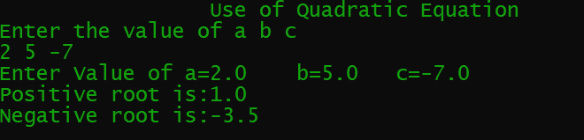

**Q.No.28 Write a Java program to get a number from the user and print whether it is positive or negative**

**Source code:**

import java.util.Scanner;

class Numbercheck{

public static void main(String[] args) {

Scanner input= new Scanner(System.in);

System.out.print("\nEnter a number :");

int num= input.nextInt();

if(num>=0){

System.out.println("It is Positive");

}

else System.out.println("It is Negative");

}

}

**Output:**

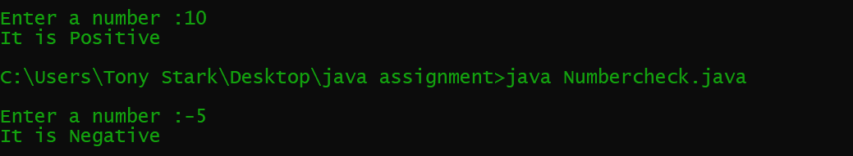

**Q.No.29 Write a Java program to find the number of days in a month.**

***Test Data***

**Input a month number: 2 Input a year: 2016 *Expected Output* :**

**February 2016 has 29 days**

**Source code:**

import java.util.Scanner;

class Numberofmonth{

public static void main(String[] args) {

Scanner input= new Scanner(System.in);

int no_of_days=0;

String month_name="Unknown";

System.out.print("\nTest Data\nInput a month number :");

int month= input.nextInt();

System.out.print("Enter Year:");

int year = input.nextInt();

switch (month) {

case 1:

month_name = "January";

no_of_days = 31;

break;

case 2:

month_name ="February";

if((year%400==0) || ((year%4==0) && (year%100!=0))) {

no_of_days = 29;

}

else

no_of_days= 28;

break;

case 3:

month_name = "March";

no_of_days = 31;

break;

case 4: month_name= "April"; no_of_days=30;

break;

case 5: month_name= "May"; no_of_days=31;

break;

case 6: month_name= "June"; no_of_days=30;

break;

case 7: month_name= "July"; no_of_days=31;

break;

case 8: month_name= "August"; no_of_days=31;

break;

case 9: month_name= "September"; no_of_days=30;

break;

case 10: month_name= "October"; no_of_days=31;

break;

case 11: month_name= "November"; no_of_days=30;

break;

case 12: month_name= "December"; no_of_days=31;

break;

}

System.out.println("Expected Output: "+month_name +" "+ year+" has "+no_of_days+ " days\n");

}

}

**Output:**

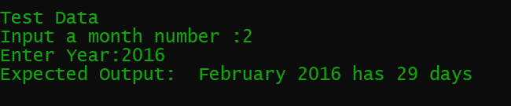

**Q.No.30 Write a program in Java to make such a pattern like right angle triangle with number increased by 1.The pattern like**

**1**

**2 3**

1. **5 6**

**7 8 9 10**

**Source code:**

class Pyramid

{

public static void main(String args[])

{

int n=1;

for(int i=1;i<=5;i++)

{

System.out.println(" ");

for(int j=1; j<i; j++)

{

System.out.print(n++);

}

}

}

}

**Output:**

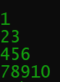

“The End”